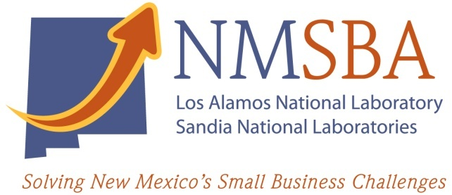
New Mexico Small Business
Assistance (NMSBA) Program
Call for Proposals
2023 Second Call Leveraged Projects

The New Mexico Small Business Assistance (NMSBA) Program is accepting Leveraged Project proposals for calendar year 2023.

The NMSBA program enables small for-profit New Mexico businesses solve critical challenges by accessing Los Alamos and Sandia national laboratories’ unique expertise and capabilities at no cost to the businesses. Individual businesses in Bernalillo and Santa Fe counties are eligible for up to $20K of technical assistance. Businesses in all other NM counties may receive $40K of assistance.

Leveraged NMBSA projects allow multiple New Mexico small businesses that share technical challenges to request assistance collectively. Projects can be funded up to the sum of the assistance for which each participating company is eligible, with total funding from $40K-$120K. Projects must be complete by the end of calendar year 2023.
Assistance is provided in the form of laboratory staff time and their use of specialized equipment. Assistance requested must not be available to the business in the private sector at a reasonable cost. The program does not provide cash or equipment to small businesses.

Proposals Due: | February 9th, 2023 (late submissions will not be accepted)
Submissions: | Submit proposals via email  SNL Proposals: Sharon Evans, sfevans@sandia.gov  LANL Proposals: Jeff Hall, jeffh@lanl.gov
Initial proposal decision: | February 17th, 2023  Successful proposals will move forward to the next phase. Additional information and a presentation are required.  Successful proposals will be moved forward to the next phase. Additional information and a presentation will be required.
Leveraged Project Presentations | March 29th & March 30th, 2023
Final project decision: | April 7th, 2023

Proposals must include the following information:
- The title of the project
- Name and contact information for the laboratory technical staff member who will lead the project
- A description of:
- the problem faced by the small businesses (250 word limit);
- how this project will address the problem (250 word limit);
- the laboratory capability utilized that is not available in the private sector at reasonable cost (100 word limit);
- the anticipated economic impact of the project on the participating small businesses (250 word limit)
Economic impact can include job creation or retention, increasing revenue, decreasing operating costs, cost avoidance, potential for funding and financing, investment in NM goods and services, etc.

- The category that best describes the technical assistance work that will be done on the project (choose one from the following list):
(1) Astronomy & Physics
(2) Advanced Modeling & Simulation
(3) Biological and Medical
(4) Business Development
(5) Chemistry and Biochemistry
(6) Computational and Computer Science
(7) Earth & Environmental Sciences
(8) Energy
(9) Engineering
(10) Manufacturing
(11) Materials Science
(12) Micro- & Nano-Technology
- Name, address (including county), and contact information for at least two New Mexico small businesses requesting the assistance.
Note: All small businesses must be for-profit, located and registered to do business in New Mexico, and meet the U.S. Small Business Administration’s Small Business Size Standards (https://www.sba.gov/document/support--table-size-standards).
- For each requesting company, the industry category that best describes the main activities of the business (select one industry for each company from the following list):
(1) Manufacturing
(2) Professional, Scientific, and Technical Services
(3) Agriculture and Natural Resources
(4) Retail & Wholesale
(5) Media & Hospitality
(6) Oil & Gas, Utilities and Mining
(7) Educational and Health Services
(8) Real Estate, Finance, Insurance and Management Services
(9) Other Services

A limited number of proposals will be selected to move forward. If the proposal is selected to continue, additional information and a presentation will be required. The additional information will be due March 22nd, 2023, and the presentations will be March 29th & 30th, 2023. The NMSBA Program Advisory Council will evaluate all presentations. Companies selected for assistance will be notified by April 7th, 2023.

For more information on leveraged projects, please contact:
Jeff Hall, 505-228-2249, jeffh@lanl.gov (Los Alamos National Laboratory)
Sharon Evans, 505-526-3602, sfevans@sandia.gov (Sandia National Laboratories)

